M&M CPU, Socket, RAM, SVM and SQL Validation

Name of Procedure: M&M CPU, Socket, RAM, SVM and SQL Validation.

Created by: Sandesh D A

Creation Date: 28/9/2021

INTRODUCTION:

This document outlines the process and expectations that are required to complete the M&M validation.

Section A

CPU/Socket and RAM Validation Plan:

We must perform these kinds of validations when there are changes made related to the CPU, Sockets and RAM in the server.

- Once we are assigned to CPU/Socket or RAM validation JCR/SR or task, check the targeted server from description and login to the server from PAM.
- If the task is related to RAM size upgrade, then go to control panel – System and Security - System and validate the RAM size as specified in the SR/task.
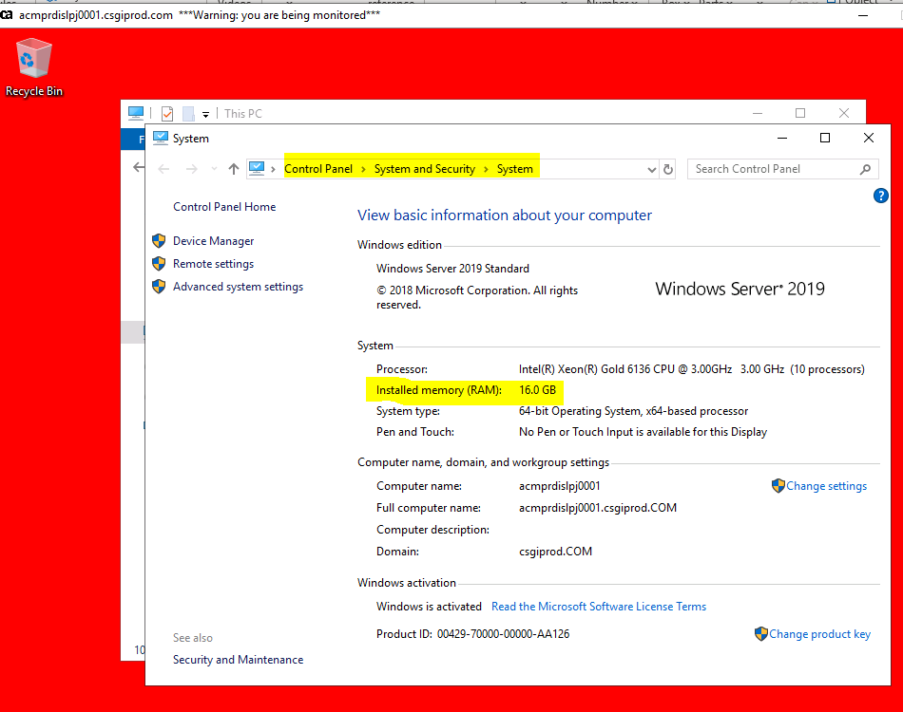
- If the task is related to CPU processors upgrade or Socket upgrade, then go to Task Manager and click on Performance, there you find the number of CPU processors (Virtual processors) and Socket size count.

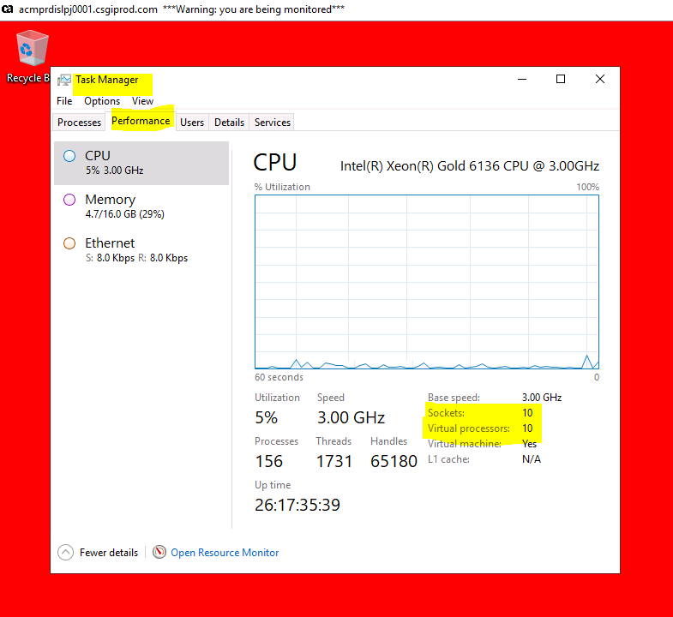

Once the above process is completed, please cross check the status of the same server in SCOM console and it should be in healthy state.

Below is the 2 sample JCRs related to the above task:

https://jira.csgicorp.com/browse/JCR-430182
https://jira.csgicorp.com/browse/JCR-312470

Section B

SVM/SQL Patching Validation Plan:

- In SVM/SQL patching validations, 1st collect the list of Servers related to Metrics and Monitoring team from excel sheet (“Remedy Group” column) which will be present in the work notes of CRQ in Remedy.
- Before the CRQ starts, please cross check the status of the servers in SCOM console as pre-validation task.
- If the server is unhealthy in SCOM, just take the screenshot and post in M&M teams channel.
- Once the SVM patching CRQ completes, please login to each server (Server with function “SCOM” in excel sheet) and go to services (just type services in search button) and cross check the below services that should be in Running state.

Microsoft Monitoring Agent
System Center Data Access Service
System Center Management Configuration

- After verifying those services, once again cross check the status of the same server in SCOM console and it should be in healthy state.
- If the server is associated to Application function in excel sheet along with the product description as Stathub, then check below services that should be in Running state.

CSG StatHubStatisticAgent CSGStatHubStatisticsAgent Windows

- If the server is associated to ProactiveNet function, then check below services that should be in Running state.

BMC ProactiveNet Event Manager bem_scom01

- After verifying those services, once again cross check the status of the same server in SCOM console and it should be in healthy state.

If the CRQ is related to SQL patching, just check the services which starts with SQL and those services should be in Running state.

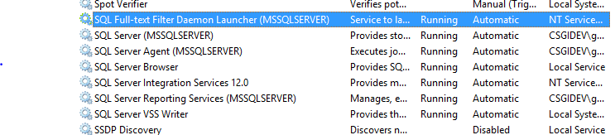
- After verifying those services, once again cross check the status of the same server in SCOM console and it should be in healthy state.

Please find the below confluence page for SVM patching CRQ schedules.

https://confluence.csgicorp.com/display/EM/Patching.

Sample JCRs for the above task.

https://jira.csgicorp.com/browse/JCR-458422 - SVM Patching
https://jira.csgicorp.com/browse/JCR-448330 - SQL Patching.

